Performing a hard reset (No checkpoints)
- Turn the console fully off by sliding the power switch on the bottom to the left
- Turn the main power back on by sliding that same switch to the right
- Keep the following buttons pressed (both triggers and ‘A’):
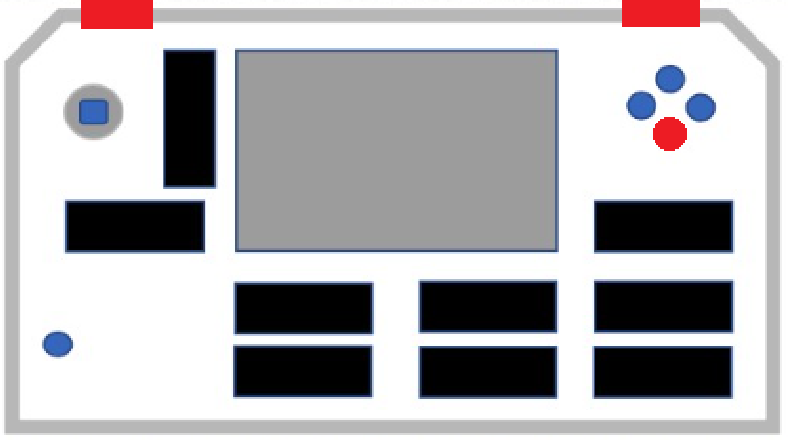

- Press (no need to hold) the power button. After 1-2 seconds you can release the button combination from step 3.

Resetting the settings to defaults
- Turn the console fully off by sliding the power switch on the bottom to the left
- Turn the main power back on by sliding that same switch to the right
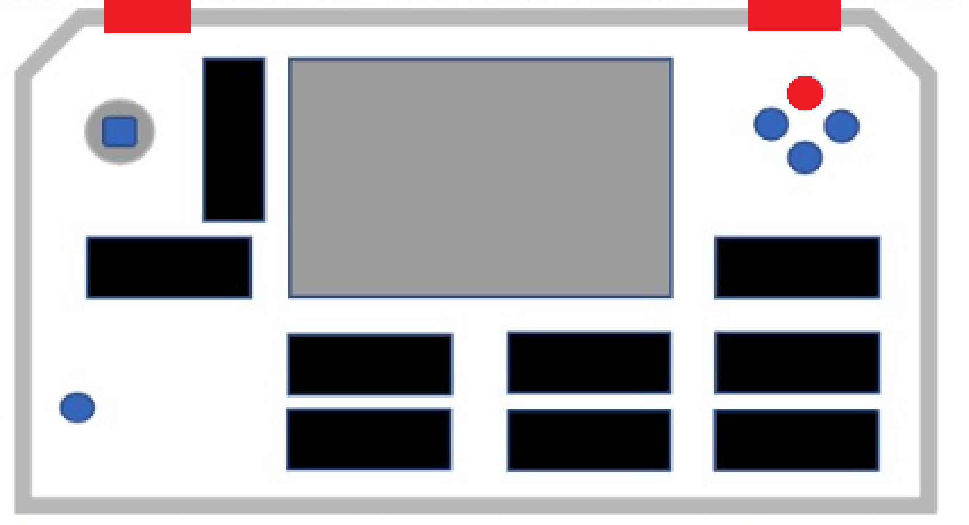
- Keep the following buttons pressed (both triggers and ‘Y’):

- Press (no need to hold) the power button. After 1-2 seconds you can release the button combination from step 3.

Going back to the menu from any app
While pressing both triggers, push the joystick down (into the console). Keep pressing them until the console goes back to the menu. (It should take 1-2 seconds max)

